EXPERIMENT 9 -A* ALGORITHM

AIM
To develop a Python program to implement the A* algorithm for finding the shortest path between a source node and a goal node.

OBJECTIVE
To demonstrate how the A* search algorithm finds the optimal path using the cost function f(n) = g(n) + h(n).

ALGORITHM
- Start.
- Initialize the Open List with the start node and create an empty Closed List to store the visited nodes.
- Select the node from the Open List that has the lowest evaluation function, f(n) = g(n) + h(n), where g(n) is the path cost and h(n) is the heuristic estimate.
- Expand the selected node, calculate the cost of its neighboring nodes, and update the Open List if a better path is found.
- Repeat the process until the goal node is reached or the Open List becomes empty (indicating that no path exists).
- Display the shortest path from the start node to the goal node and Stop.

SAMPLE CODE
graph = {
'A': [('B', 1), ('C', 3)],
'B': [('D', 3), ('E', 6)],
'C': [('F', 5)],
'D': [],
'E': [('G', 2)],
'F': [('G', 2)],
'G': []
}

heuristic = {
'A': 7,
'B': 6,
'C': 4,
'D': 3,
'E': 2,
'F': 1,
'G': 0
}

def a_star(start, goal):
open_list = [(start, 0)]
visited = set()

while open_list:
open_list.sort(key=lambda x: x[1] + heuristic[x[0]])
node, cost = open_list.pop(0)

if node == goal:
print("Goal Reached:", goal)
return

if node not in visited:
print("Visited:", node)
visited.add(node)

for neighbour, weight in graph[node]:
if neighbour not in visited:
open_list.append((neighbour, cost + weight))

a_star('A', 'G')

FLOW CHART
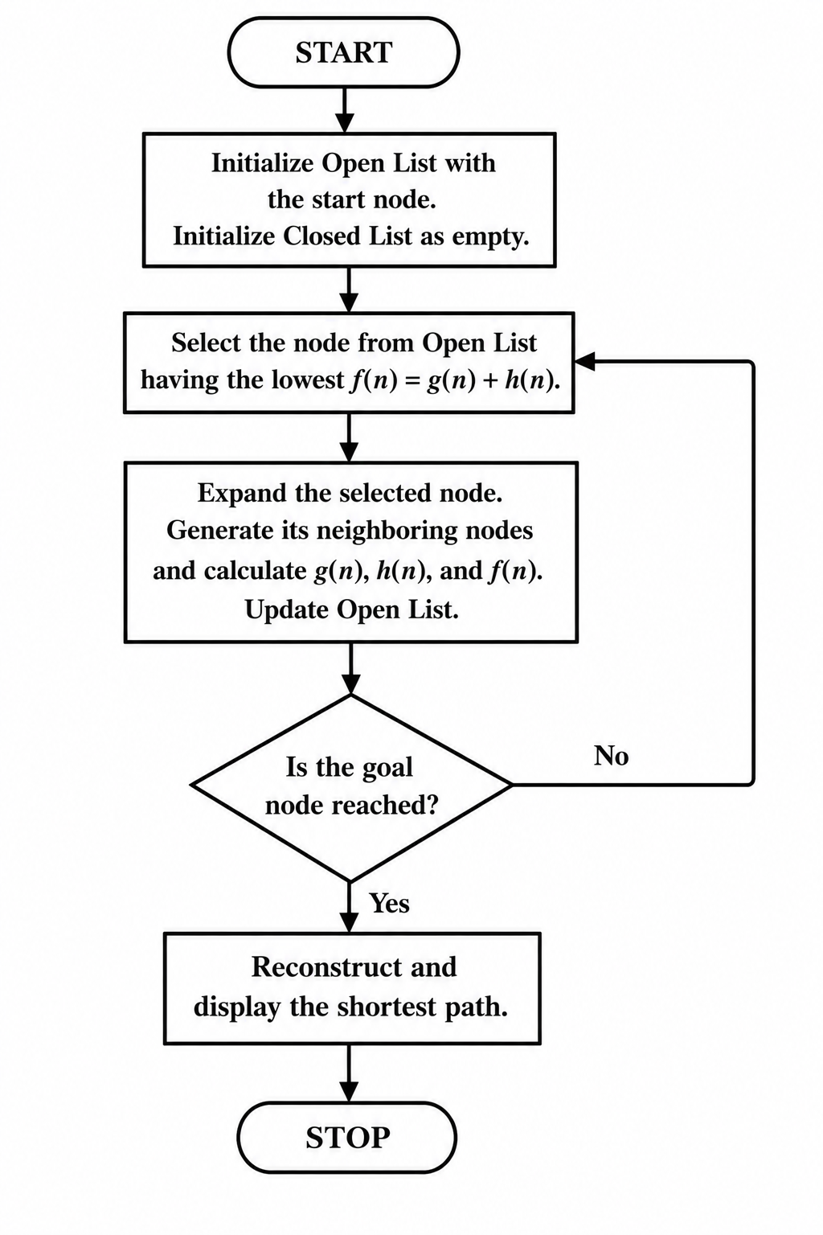

OUTPUT
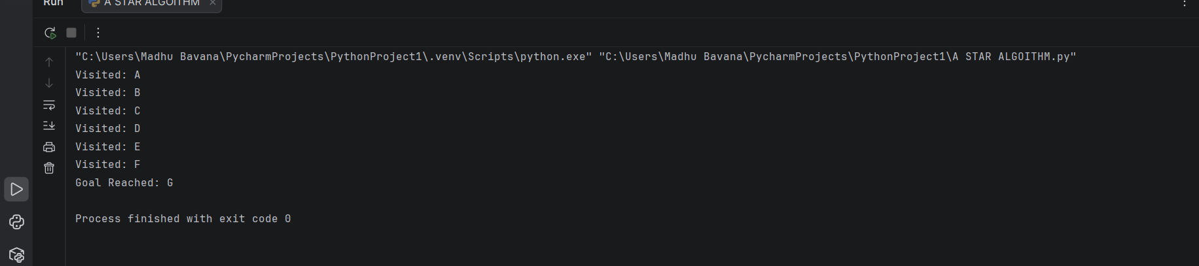

RESULT
The Python program was executed successfully. The vacuum cleaner agent sensed the environment, cleaned all the dirty rooms, and displayed the final status of each room.

